Addis Ababa University
Data Science and Cloud Computing in Bioinformatics

Project 1

Title: Single-Cell RNA-seq Analysis of Peripheral Blood Mononuclear Cells to Identify and Characterize Distinct Immune Cell Populations

Name: Beyene Chalchisa
ID N_{O}: GSR/4596/18

Dataset Source Information
Dataset: 3k PBMCs from a Healthy Donor
Cells: 2,700 detected cells
Species: Human
Sample: PBMC
Technology: 10x Genomics Universal 3'
Official 10x page: 3k PBMCs from a Healthy Donor — 10x Genomics
Project File: scRNAseq_PBMC

Final Project Report Single-Cell RNA-seq Analysis
- Biological Problem and Research Question
  - Biological problem
Peripheral blood mononuclear cells (PBMCs) consist of multiple immune-cell populations with distinct transcriptional profiles. Single-cell RNA sequencing (scRNA-seq) allows these heterogeneous populations to be separated computationally according to their gene-expression patterns (al., 2017)
  - Research question
- What major immune-cell populations are present in the PBMC3K dataset?
- how are they distributed across the identified cell populations?
- which marker genes characterize these populations?
  - Objectives
- The analysis aimed to:
- Perform quality control and filtering of PBMC3K single-cell data.
- Normalize gene-expression measurements.
- Identify highly variable genes.
- Reduce dimensionality using PCA.
- Construct a cell-neighbor graph and identify clusters.
- Visualize cell populations using UMAP.
- Identify marker genes for the resulting clusters.
- Annotate clusters according to known immune-cell marker genes.
- Quantify the major cell populations.
- Develop a reproducible Snakemake workflow and execute it through SLURM/HPC.
1.4, Description of the major elements
data/ holds the initial and intermediate datasets of single cells. The raw/ folder holds the PBMC3K files in their original form, whereas processed/ holds the datasets that are generated after each analysis step.
scripts/ holds the Python scripts utilized for the analysis. Each script is responsible for a certain analysis stage, such as quality control, normalization, PCA, clustering, gene-marker search, and cell-type annotation.
results/ holds the outputs of the analysis process. Figures are kept in results/figures/, numerical outputs and tables in results/tables/, marker-gene results in results/markers/, cell type annotation in results/annotation/, and biologically meaningful outputs in the corresponding directories.
hpc/ holds the SLURM batch script to run the Snakemake workflow on the local WSL-based HPC infrastructure.
logs/ stores execution logs and error messages. These are useful for monitoring the workflow and troubleshooting failed jobs.
Snakefile defines the complete computational workflow and the dependencies between analysis steps. Snakemake ensures that outputs are generated in the correct order and that completed steps do not need to be unnecessarily repeated.
- Dataset and Public Repository
The analysis used the PBMC3K single-cell RNA-seq dataset. The dataset contains peripheral blood mononuclear cells profiled using single-cell RNA sequencing and was retrieved through the publicly available PBMC3K dataset provided through the Scanpy/10x Genomics ecosystem. The initial dataset contained 2,700 cells × 32,738 genes and data were stored locally in “data/pbmc3k_raw.h5ad”. The “H5AD’ format was used because it is designed for efficient storage of annotated single-cell expression data using the “AnnData framework”.
- Data Retrieval
The dataset was retrieved programmatically using Python and Scanpy. The initial loading script was “scripts/01_load_pbmc3k.py”. The workflow loaded the dataset and saved the raw AnnData object as “data/pbmc3k_raw.h5ad”. This programmatic retrieval improves reproducibility because the dataset can be obtained and processed using a scripted workflow rather than manually manipulating files.
- Data Wrangling
Data wrangling was performed to ensured and quality of the dataset that the dataset was structurally appropriate for downstream single-cell analysis using the script of “scripts/03_data_wrangling.py” and summary information generated in files concerning:
- number of cells
- number of genes
- missing values
- duplicate identifiers
- expression characteristics
- mitochondrial genes
- ribosomal genes
- cell-level metrics
- gene-level metrics
Table 1, Data Wrangling

- Quality Control and Filtering
Quality control (QC) and filtering were performed to remove low-quality cells and improve the reliability of downstream single-cell RNA-seq analysis. For the PBMC3K dataset, QC metrics were examined at the individual-cell level, including the number of detected genes, total transcript counts, and mitochondrial gene expression. Cells with poor-quality profiles were removed before normalization and downstream analysis. The processed QC dataset was saved as ‘data/processed/pbmc3k_qc.h5ad’ in the project. The important point is that the filtering was performed computationally rather than manually.
Table 2: Indicial and After QC and filtering, the final analyzed dataset
Initial cells | 2,700
Final cells | 2,643
Removed | 57

Figure 1: QC matrics
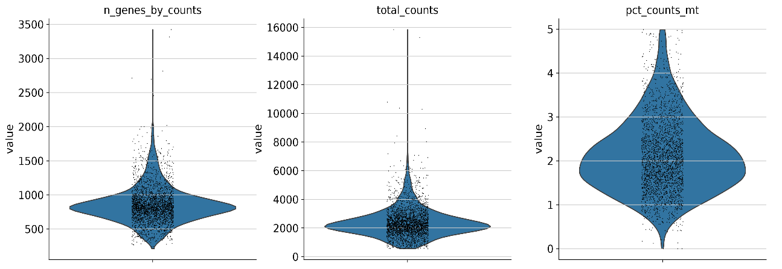

Figure 2: QC Counts Vs Gene Counts
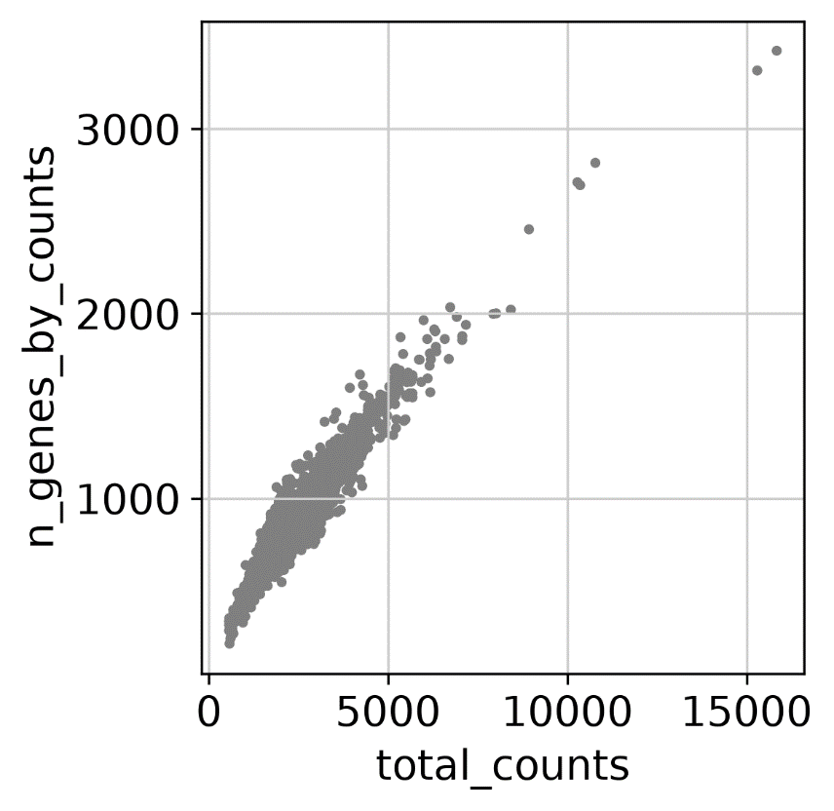
- Normalization and Highly Variable Genes
Following QC, the gene expression was normalized to allow comparability of expression values across cells. The main idea behind picking highly variable genes is to conduct further dimensional reduction and clustering with genes, which carry biological variations between cells. The normalization procedure was performed using ‘scripts/03_normalization.py’ and the normalized dataset was saved as: “data/processed/pbmc3k_normalized.h5ad”.
figure 3, shows the effect of normalization for library size of the PBMC3K single-cell RNA-seq dataset. It can be observed that before normalization the total number of transcripts detected differs significantly between the cells. It is mostly because of the difference in sequencing depth and efficiency of RNA capture and not due to biological reasons.
Following normalization, the gene expression values for each cell were rescaled to have the same library size for all cells – 10,000 counts. The further log1p transformation helped reduce the effect of high-abundance genes.
Figure 3: Before and After Normalization of Gene
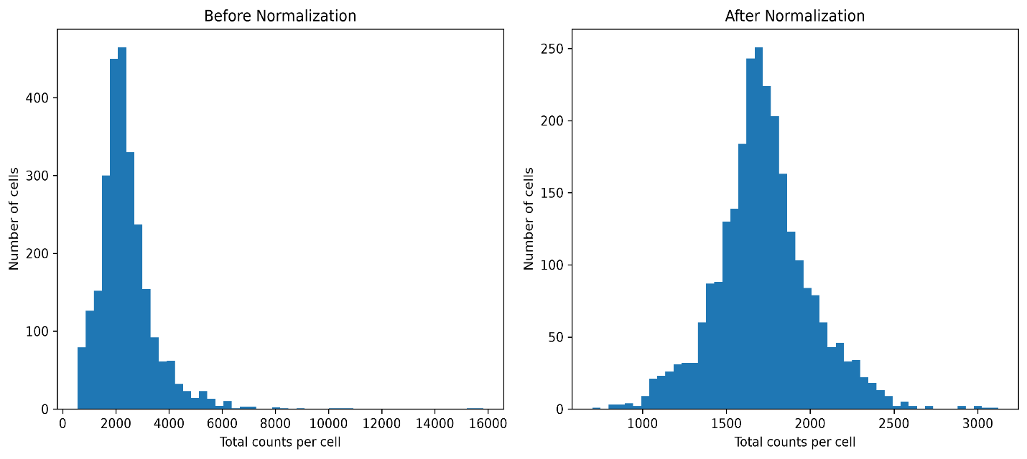

- Principal Component Analysis
Principal Component Analysis (PCA) was used for dimensionality reduction. The PCA workflow was implemented in ‘scripts/05_pca.py’ and produced in ‘data/processed/pbmc3k_pca.h5ad’.
Figure 4, PCA variance-ratio analysis shows the proportion of total gene-expression variation explained by each principal component. The first principal components explain the largest proportion of variation, while the contribution of subsequent components progressively decreases. This pattern indicates that a relatively small number of principal components capture much of the major structure in the dataset.
Although, Figure 4, PCA of PBMC3K cells based on gene by counts. Each dot is a single cell, and PC1 & PC2 capture the most significant variance within the gene expression data. The PBMC cells cluster into several discrete groups in PCA space, reflecting a high level of transcriptional variability among the PBMC cells. The color gradient reflects the number of genes that are expressed within each cell, with dark colors corresponding to lower numbers of detected genes and yellowish-green colors for higher numbers of detected genes. In the majority of cases, the number of detected genes is relatively small, while in a few cases, there are larger numbers of detected genes. This distribution demonstrates that sequencing depth and gene detection have a role in generating variance within this dataset. However, the formation of distinct clusters also points towards biological heterogeneity.

Figure 4: PCA variance-ratio and PCA of PBMC3K cells based on genes by counts.
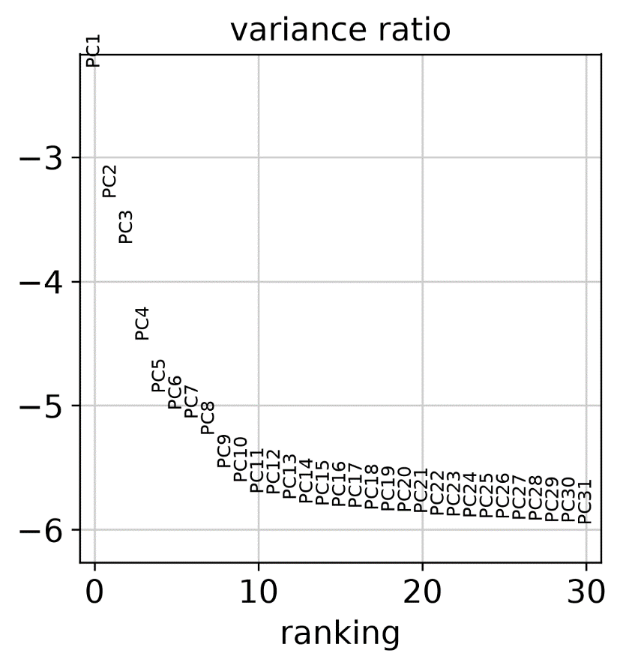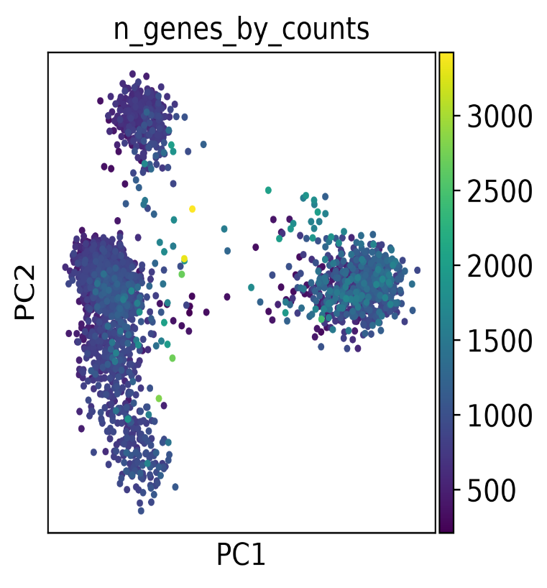
- Neighbor Graph and Clustering
A nearest-neighbor graph was constructed from the PCA representation. Figure 5 displays, the Nearest-neighbor graph of PBMC3K cells. Every node denotes one single cell while each edge is a measure of transcriptional similarities of nearby cells in terms of PCA representation. Similar cells with regard to gene-expression profiles have connected neighborhoods. This graph reflects the structure of cellular similarities and used for the foundation/formation of Leiden clustering and UMAP visualizations. The graph does not help in determining biological identity. Because the nearest-neighbor graph shows computational similarity, not biological identity. this task is carried out later by analyzing specific markers within each cluster.
Figure 5: Nearest Neighbor Graph
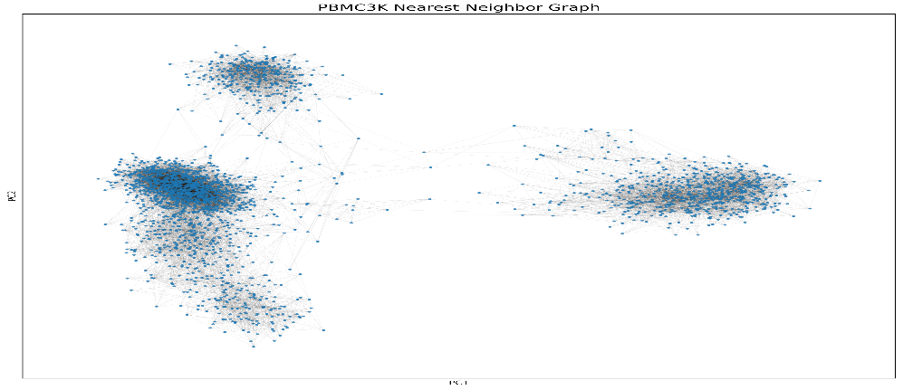
- Uniform Manifold Approximation and Projection (UMAP) Visualization
Uniform Manifold Approximation and Projection (UMAP) was used to visualize the high-dimensional single-cell data in a low-dimensional space. The UMAP workflow was implemented using “scripts/08_umap.py’, and the result dataset was stored as ‘data/processed/pbmc3k_umap.h5ad’. UMAP provides an intuitive visualization in which transcriptionally similar cells tend to occur near one another. Therefore, the resulting structure was used together with marker-gene information for cell-type interpretation.
According to the UMAP plot (Figure 6), there is evident transcriptional heterogeneity for the 2,643 PBMC3K cells where Leiden clustering has revealed a number of different cellular populations. Using cluster-based UMAP, it can be said that the cells in each cluster are rather similar in terms of gene expression. Given the biological annotation, it can be stated that the major cellular populations comprise B cells, dendritic cells, megakaryocytes, monocytes, NK cells, and T cells. The T cells and B cells form larger populations, while monocytes and NK cells are located in different areas of the UMAP, and smaller populations including dendritic cells and megakaryocytes are also distinguishable. The placement of some populations relatively close to each other, such as the T and NK cells, can be explained by the fact that these immune cells possess similar transcriptional features, while the distant monocyte, B-cell, and megakaryocyte populations reveal dissimilar transcriptional characteristics.
Figure 6: Uniform Manifold Approximation and Projection (UMAP) and cell types Visualization
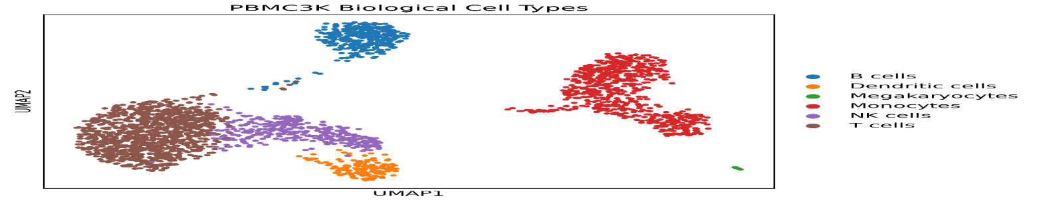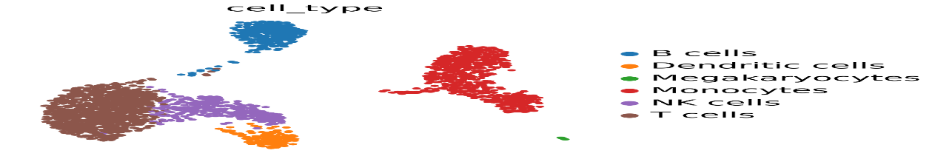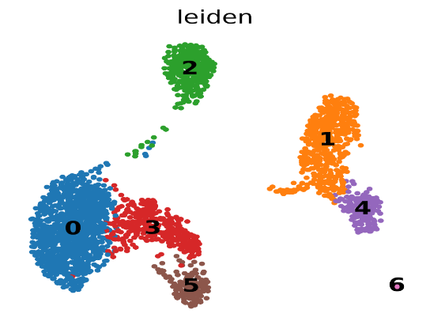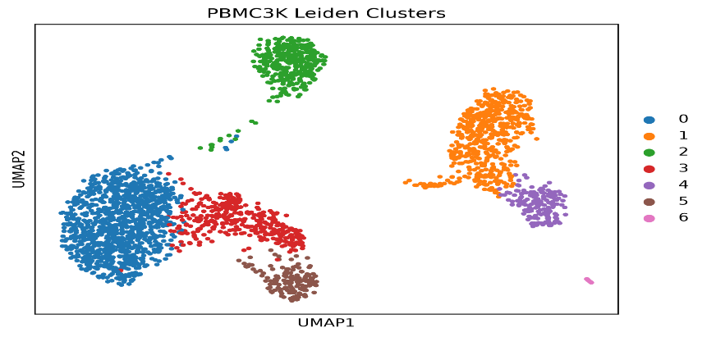
- Biomarker Gene Analysis
Differential marker-gene analysis was performed for the identified clusters. Marker genes provide evidence for assigning biological identities. It is clustered and produced the workflow of ‘data/processed/pbmc3k_markers.h5ad’. These genes were interpreted together with cluster expression patterns rather than using a single gene as the single basis for annotation.
Table 2, Biomarker information
Cell population | Representative markers
T cells | CD3D, CD3E, TRBC1
B cells | MS4A1, CD79A
NK/cytotoxic cells | NKG7, GNLY
Monocytes | LST1, FCGR3A
Dendritic cells | FCER1A, CST3
Megakaryocytes | PPBP, PF4
- Cell-Type Annotation
The cell annotation was achieved through the integration of the results obtained from the Leiden clustering algorithm with marker genes of each cluster and known markers of immune cells. This process was executed through the use of scripts/10_annotation.py and generated an annotated file data/processed/pbmc3k_annotated.h5ad. The final annotated dataset included 2,643 cells, which were classified into six immune-cell populations and one small cytotoxic/NK-like population. T cells made up the largest cell population (1,096 cells), representing 41.47% of the total population. Monocytes were the second in number, with 651 cells (24.63%). B cells and NK cells constituted 352 (13.32%) and 345 (13.05%) cells, respectively. Dendritic cells made up 5.90% (156 cells), while megakaryocytes formed a small population of 32 cells (1.21%). Finally, a very small cytotoxic/NK-like population included 11 cells (0.42%). The annotated UMAP clearly separates biologically meaningful immune-cell populations, as expected from PBMCs.

Python output on ubuntu
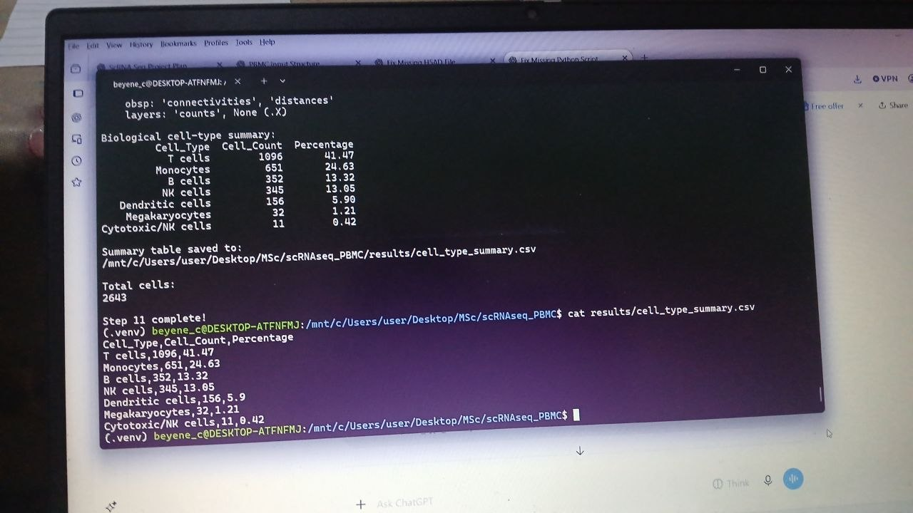
Figure 7: Cell-Type Annotation and composition
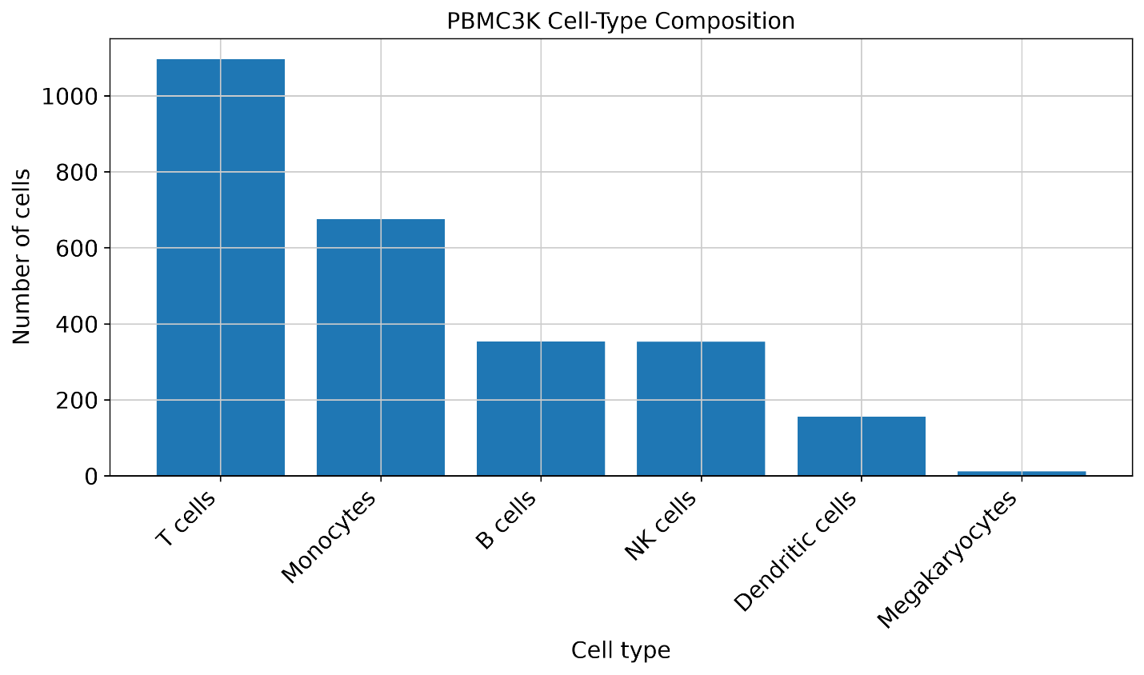
The figure 7 provides biological evidence for the annotation, rather than simply assigning cell names based on cluster numbers.The dot plot indicates that there is unique gene expression between the PBMC3K clusters, thereby providing a rationale for their biological interpretation. In the case of T cells, strong expression of CD3D and CD3E was observed, while B cells had markers such as MS4A1, CD79A, CD74, and HLA-DRA. On the other hand, NK/cytotoxic cells expressed NKG7, GNLY, and GZMB. In the case of monocyte populations, LST1 and inflammation markers such as S100A8 and S100A9 were found to be highly expressed. The cluster that expressed CD74, HLA-DRA, LYZ, and CST3 could possibly be an antigen presenting myeloid/dendritic population. Lastly, PPBP and PF4 expressions helped identify the megakaryocyte population.
Figure 7: Dot plot Biological Annotation
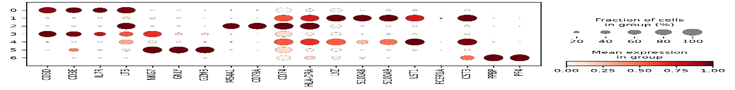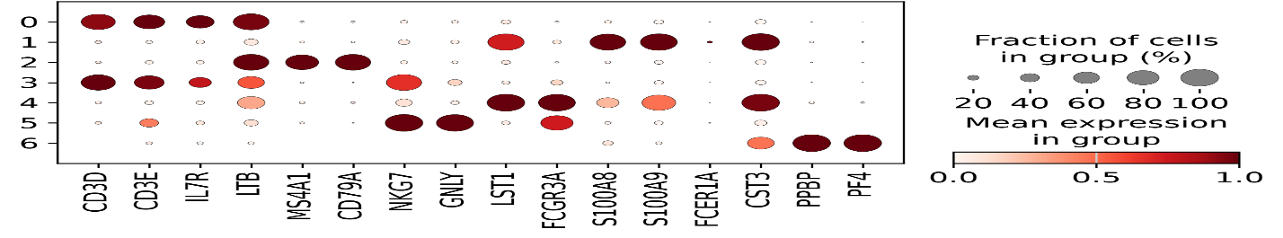
- Projects Structural tree
The project structural tree shows how the PBMC3K single-cell RNA-seq project is organized into folders, input data, analysis scripts, results, and computational workflow files. It provides a clear overview of where each component of the project is stored and how the different parts of the analysis are connected. Python scripts were organized according to the sequential stages of the single-cell RNA-seq workflow, from data loading and quality control to clustering, marker-gene identification, cell-type annotation, and biological interpretation. Results were further separated into figures, tables, marker genes, annotations, and reports. The project also included a SLURM batch script and a Snakemake workflow to support reproducible and automated execution of the analysis.

Figure 8, project structural tree
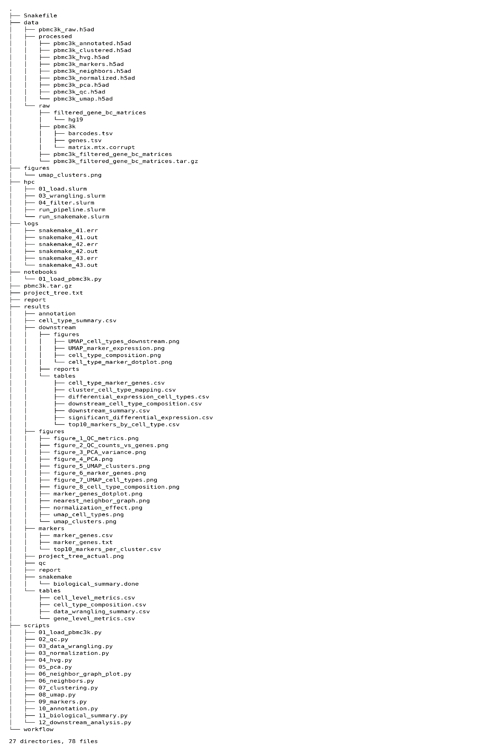
- Reproducible Snakemake and SLURM/HPC Workflow

A reproducible Snakemake workflow was created to perform the PBMC3K single-cell RNA sequencing analysis from loading data to quality control, normalization, highly variable gene selection, principal component analysis, neighbor graph creation, Leiden clustering, uniform manifold approximation and projection (UMAP), marker gene selection, cell type classification, and biological interpretation. Each workflow rule contained the required input and output files, which made Snakemake automatically figure out the dependencies and avoid unnecessary computation. The workflow was run via SLURM batch script with 4 CPUs and 3500 MB of memory in the local WSL-based HPC system. Submitted SLURM job was successfully run, and Snakemake showed that all required outputs were already up to date. Logs of the execution process were saved in the logs/ directory.

- Overall Biological Interpretation

The analysis demonstrates that PBMC3K contains a heterogeneous mixture of lymphoid, myeloid, and platelet-lineage populations:
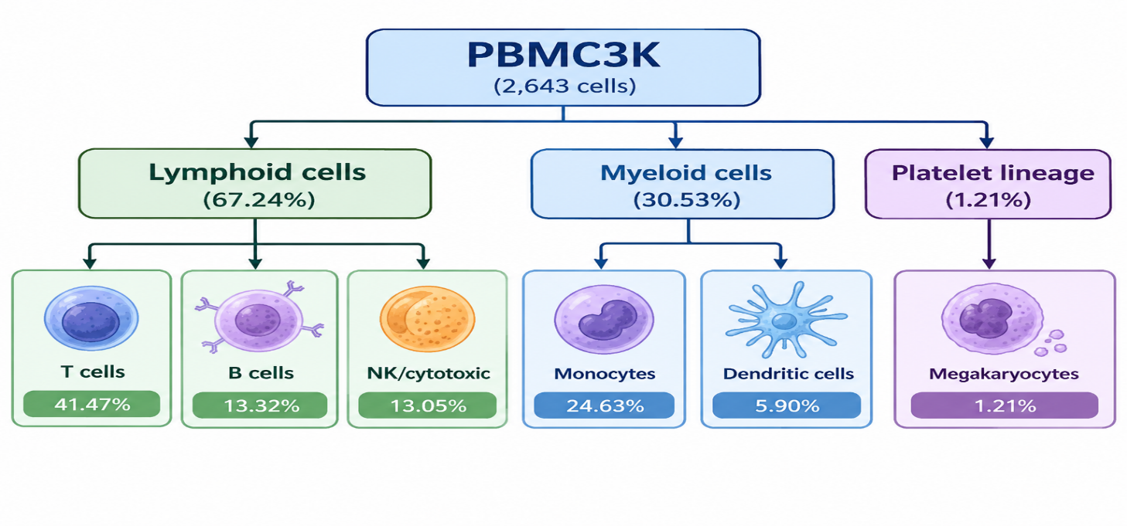

Based on the UMAP plots and the marker genes analysis, it could be inferred that the computational clusters represent biologically relevant immune cell populations. It is crucial to note that while cluster numbers are not able to identify the biological relevance, biological identity was assigned based on the examination of the marker genes expression. In particular, the report states that the nearest neighbor graph indicates transcriptional similarity and not biological identity of cells. The annotation is based on marker analysis.

Conclusions

PBMC3K analysis indicated significant cellular heterogeneity and revealed different immune cell populations by virtue of their transcriptional signatures. T-cells constituted the major population followed by monocytes, B-cells, and NK-cells. Dendritic cells, megakaryocytes, and cytotoxic/NK-like populations constituted the minority groups of cells. Marker genes provided biological validation of these annotations as follows: T-cells – CD3D/CD3E, B-cells – MS4A1/CD79A, NK/cytotoxic cells – NKG7/GNLY, monocytes – LST1/FCGR3A, dendritic cells – FCER1A/CST3, and megakaryocytes – PPBP/PF4.

The original PBMC3K 10x Genomics single-cell dataset/work demonstrating identification of distinct PBMC populations using scRNA-seq.

